**INTERNCROWD INTERNSHIP**

**Name : Sarthak Hanchate**

**Task 2 : HOST A DYNAMIC WEBSITE**

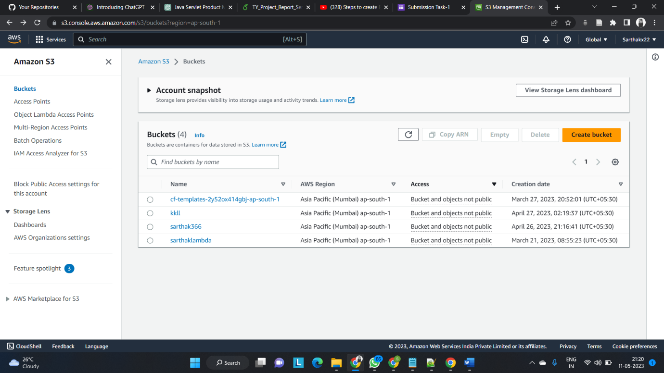Step 1 : Create Bucket using Amazon S3

Step 2 : Bucket created with name interncrowd

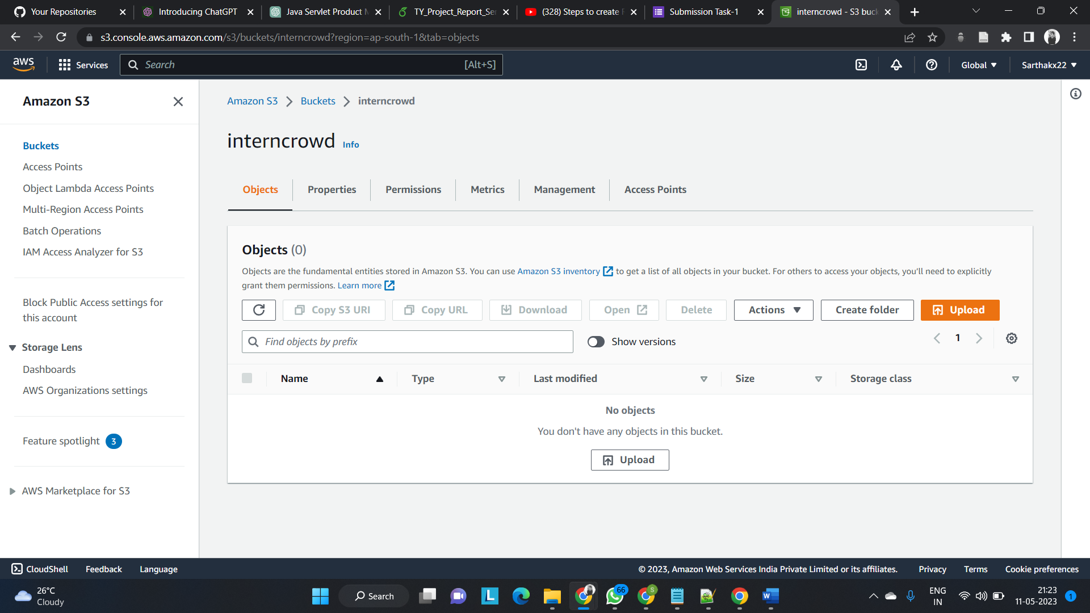

Step 3 : Changing the properties of bucket i.e Enabling Static Website Hosting

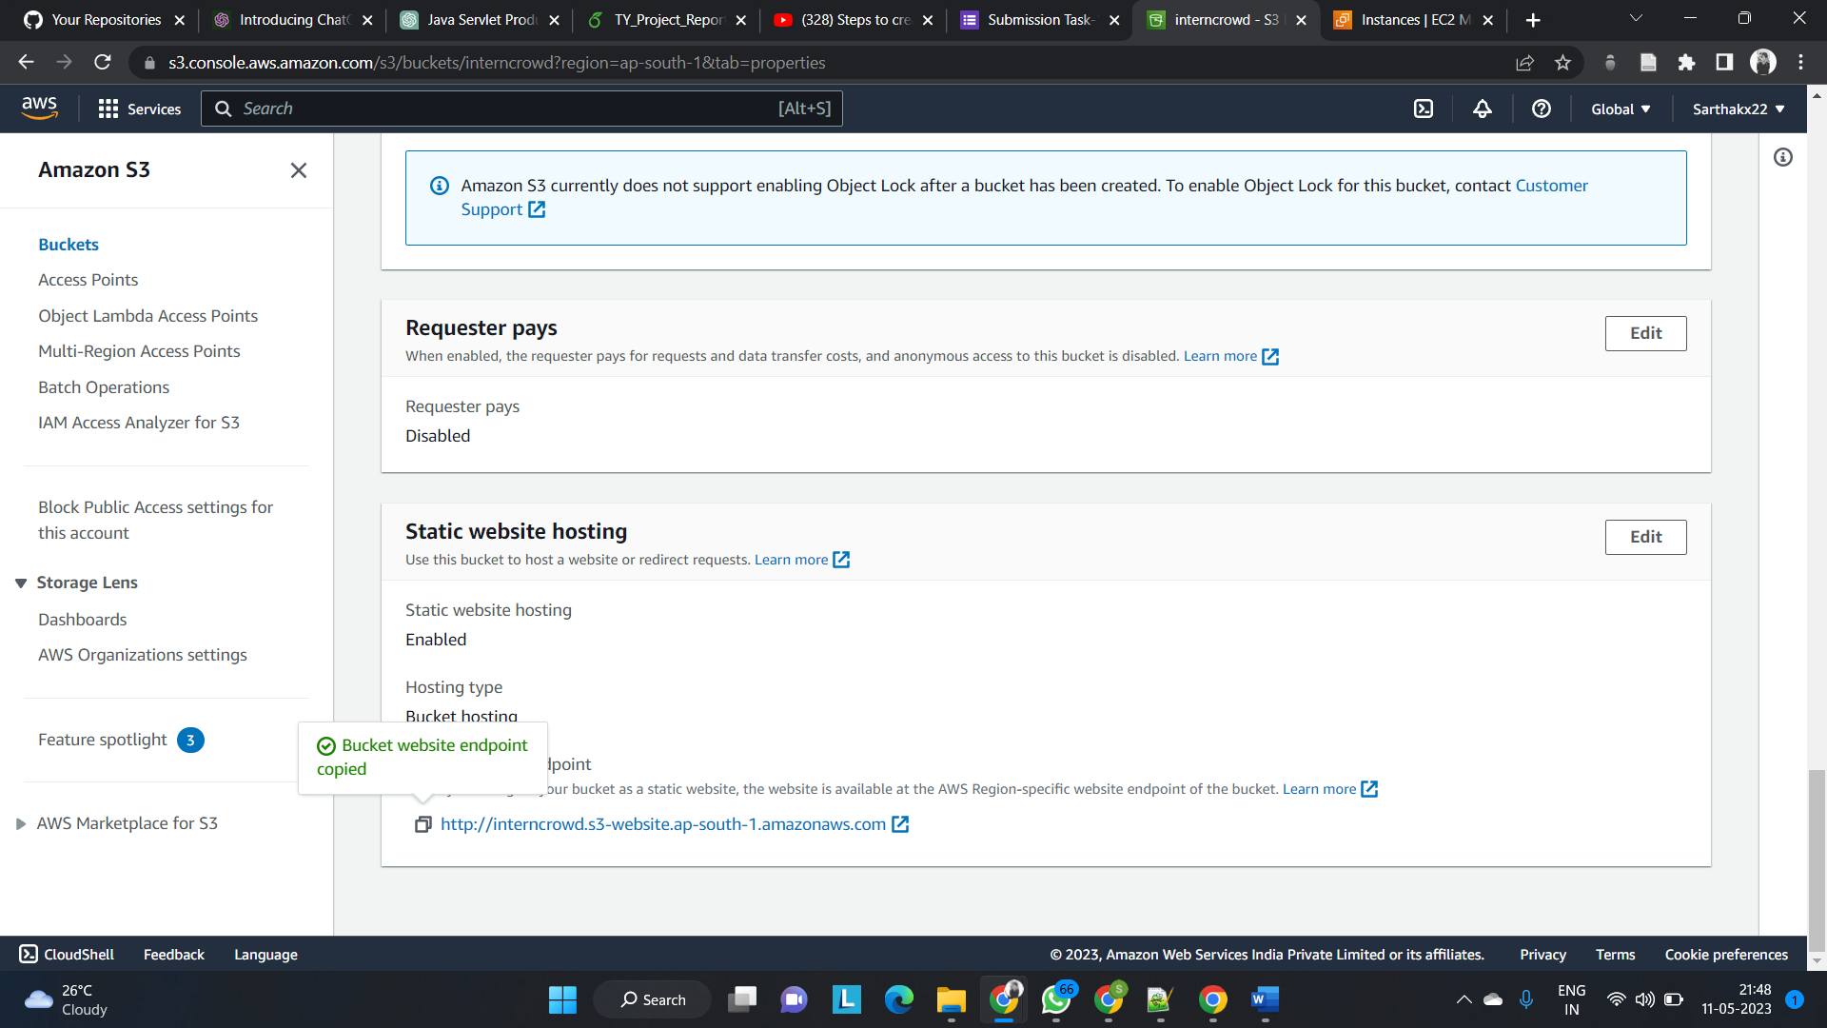

Step 4 : Create EC2 instance of windows to host the website on Microsoft Edge

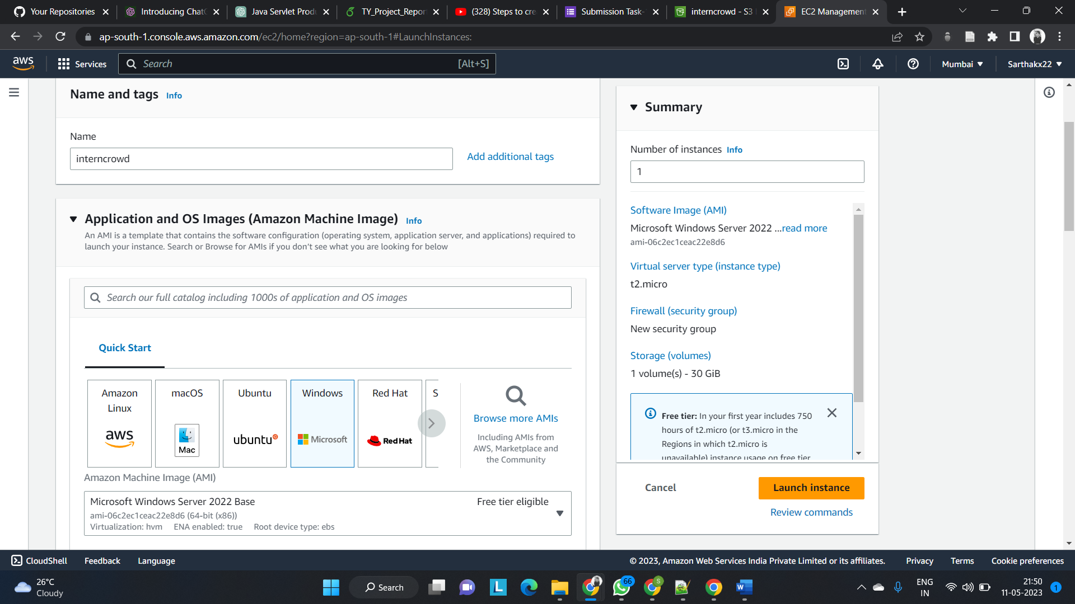

Step 5 : Launch the instance and connect to it and download the remote desktop file

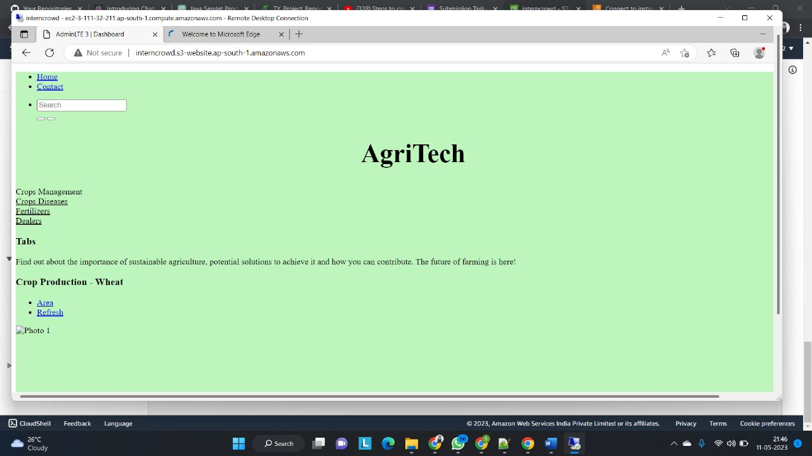

Hosted a Dynamic Website using Amazon S3 and Windows EC2 Instance

Actual Website :

